MCj03206820000[1]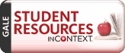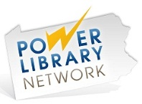

How Do I Research  
 Controversial Topics?

***Will I need to use Google or any websites for this project?***

You should be able to find all the information you need in books and these databases without even using Google!

***Which search terms do I use?***

Use simple keywords and be sure to try synonyms for the topic you are doing. Search for:

- global warming OR climate change

- school dress code OR school uniforms

**The MHS Library Research wiki -** [**www.methactonlibrary.wikispaces.com**](http://www.methactonlibrary.wikispaces.com) **- has all of the links you need to successfully research**

**Controversial Topics.**

* Go to the Methacton School District website – [www.methacton.org](http://www.methacton.org) and use the drop-down menu on the top left to get to the Methacton High School homepage.
* Click on the link for Library, found on the maroon navigation bar in the top center of the page.
* Once on the Library page, look for the blue column that says Research. Click on the first link for MHS Library Research Wiki.
* Once this page opens in a new window, click on the box that says **Controversial Topics**.

**Gale Opposing Viewpoints and Student Resources in Context:** Opposing Viewpoints  
 provides information on both sides of today's hottest social issues. Student Resources  
 in Context provides a premium selection of reference and full-text periodicals and  
 newspapers. Simply type your search in the box or browse the topics listed. If you are researching a SCIENCE topic, be sure to check out Gale’s Science in Context database. THERE IS NO PASSWORD FROM SCHOOL; AT HOME THE PASSWORD FOR BOTH DATABASES IS **methacton**.

ProQuest’s **eLibrary** provides access to more than 2,000 full-text and multimedia sources.  
 Popular topics are given a special treatment that includes related images, timelines, links,   
 and more. THERE IS NO PASSWORD FROM SCHOOL; AT HOME THE USERNAME is **methacton** AND THE PASSWORD IS **warriors**.

**Access World News** provides full-text newspapers from around the world, all browsable by issue or searchable by topic. Results can also be organized by date, country, and publication. THERE IS NO PASSWORD FROM SCHOOL; AT HOME THE USERNAME is **methacton** AND THE PASSWORD IS **warriors**.

**POWER Library:** Try searching under “Newspaper/Magazines” in Masterfile Main Edition   
 and or Newspaper Source Plus for information on controversial topics. Use the Access   
 Pennsylvania database to search for books from other libraries across the state. AP Images can be used to search for images. USE AT HOME REQUIRES A PUBLIC LIBRARY CARD NUMBER.

**Don’t forget to search the Methacton Library catalog online to find more information on your topic. We have many books on controversial topics that include short essays that are easy to read and extremely helpful. The link to the catalog is found on the Methacton Library website and wiki.**

**Please ask the library staff if you need help finding books.**

# Controversial Topics to Explore

**Adoption**: international, same-sex couples, bi-racial, adoption policies

**Animals**: experimentation, animal rights, zoos, endangered species

**Business**: corporate corruption, government intervention, deregulation, sweatshops, outsourcing, gambling

**Cell phones**: sexting, cell phones and driving, other dangers, use in school

**Censorship**: Internet, music, other media, in schools

**Children’s rights**: child abuse and neglect, child labor, child trafficking/slavery, child soldiers, curfews, age of consent

**Crime**: mandatory minimum sentencing, juvenile crime, prisons, capital punishment, gun control, concealed weapons

**Diseases and disorders**: infectious diseases, Asperger’s syndrome, autism, cerebral palsy, fetal alcohol syndrome, food-borne diseases, depression and bipolar disorder, mental disorders, eating disorders, obsessive-compulsive disorder, HIV/AIDS, post-traumatic stress disorder, sudden infant death syndrome, Alzheimer’s disease, cancer

**Economics**: foreign aid, advertising, chain stores, consumer culture, consumer debt, budget deficit

**Education**: standardized testing, charter schools, school funding, homeschooling, online education, school policies, cheating, plagiarism, prayer in school, violence in schools, affirmative action, student loans, school uniforms

**Employment**: affirmative action, joblessness, immigration, Family Medical Leave Act, homelessness, labor unions, minimum wage

**Environmental**: garbage and recycling, green cities, green lighting, global warming, renewable/alternative energy sources, oil, pollution

**Food**: genetically modified food, junk food in schools, fast food, food politics, childhood obesity, vegetarianism

**Gender issues**: gays in the military, transgender people, gay marriage, gay parenting/adoption

**Healthcare**: socialized medicine, universal healthcare, Medicare

**Health-related issues**: abortion, deafness and hearing impairment, birth control, vaccinations, teen pregnancy, flu pandemics, disposal of the dead

**Internet**: regulation, social networking, cyberbullying, cybercrime, pornography, privacy, identity theft

**Language in America**: English as the national language, struggles of English language learners

**Media**: celebrity culture, sexualization of children, television, YouTube, video games, beauty pageants, fashion industry, advertising

**Medical ethics**: extending human life, cloning, stem cell research, reproductive technologies, sex preselection, organ donation and sale, euthanasia, abortion

**Medicine**: vaccinations, prescription drug problems, overmedication

**Natural disasters**: causes, disaster relief

**Politics and Government**: U.S. two-party system, foreign oil dependence, campaign finance, electoral college, Social Security, immigration, government intervention in business, power of the wealthy, space exploration, terrorism, extremism

**Student life**: binge drinking, cognitive-enhancing drugs, hazing, Greek organizations, college athletics, student loans

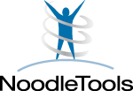Noodle Tools Guide

LOG IN: Log into your Methacton Google Account *[userID@student. methacton.org]* and look for the Noodle Tools icon on the Student Intranet Launchpad. Or, use the Noodle Tools link provided on the MHS Library Website.

PROJECT: Create a project in MLA Advanced format. Click on “Share project with your teacher’s dropbox” and enter the Assignment Dropbox name:

SOURCES: Go to the Works Cited page and use the dropdown menu to add a source to your project by creating a citation. If you are using a printed book, select “Book” from the list. If using an online database, select “Database.”

**TIPS FOR CHOOSING A CITATION/SOURCE TYPE**

* Most articles found in an online database were originally another type of source – a newspaper, journal, magazine, reference, etc. After selecting “Database,” then select the original source type.
* When you find a source in eLibrary or Gale (Opposing Viewpoints, Student Resources, etc.), it tells you what type of source it is on the search results page. Pay attention to this and choose this type of source after you select that it was found in a database. In Literature Resource Center, look at the top of the page under “Source” to see what the name of the source is. Click on the link to find out the type of source.
* Information found in a database that says “Book” is almost always a Reference Source. You can tell because it will list the title of the article or section along with the title of the book. Only use “Book” as the source type if you are reading an entire book online (like something from Google Books) or using a printed book.

CITATIONS: All spots in the Noodle Tools citation form with an *asterisk* must be completed. As much additional information as possible should also be added. To find the information, look at the citation given at the bottom of each article in a database. All of these details should be entered into the citation form. If using a printed book, look at the title and copyright pages.

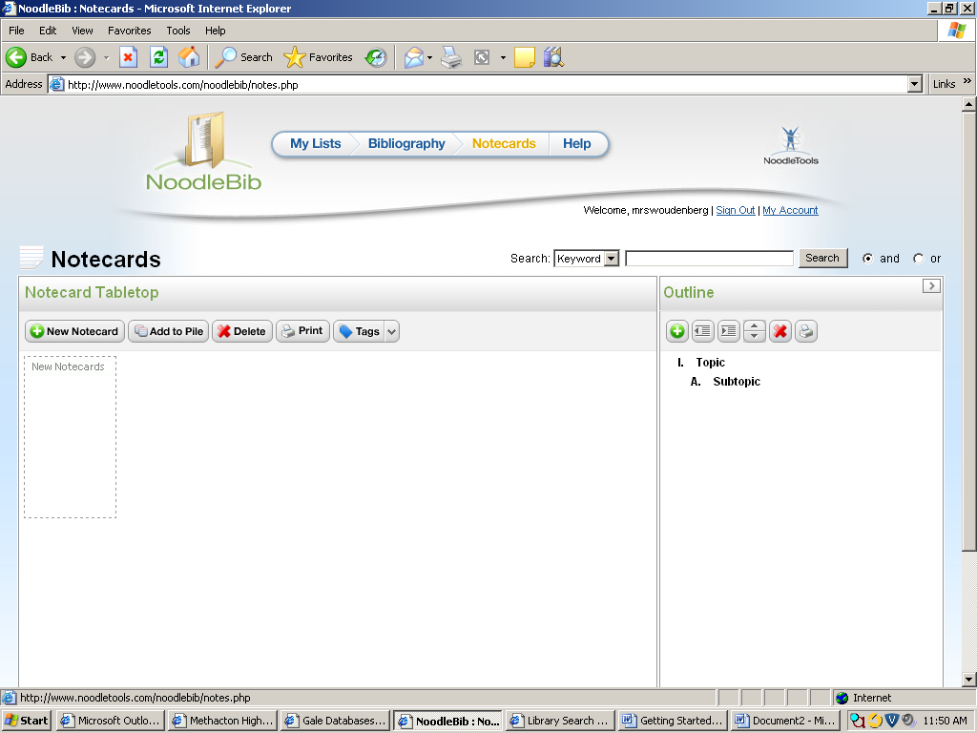MAKING NOTECARDS

1. 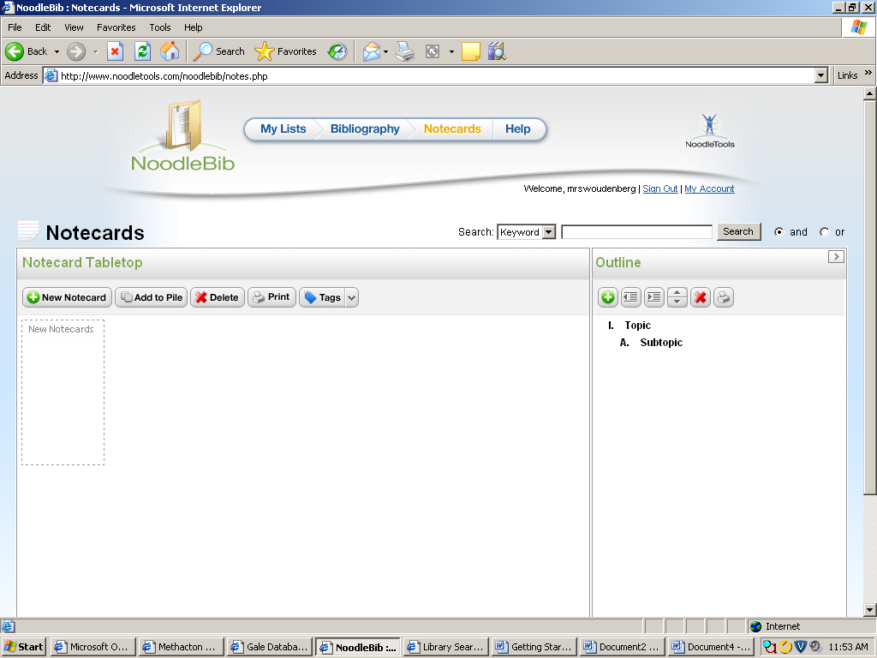Click on the Notecards tab at the top of the page. Once on the Notecards page, click on New Notecard.
2. Name your notecard with the MAIN IDEA, then SELECT which source this notecard goes with.
3. A notecard allows you take three different types of notes: **Direct Quotation**, **Paraphrase**, and **My Ideas**. Take notes in whichever section applies. This helps you avoid plagiarism!
4. You can add tags to your notecards so later you can easily organize and find them according to whichever tag or topic/slug you assign to them.
5. 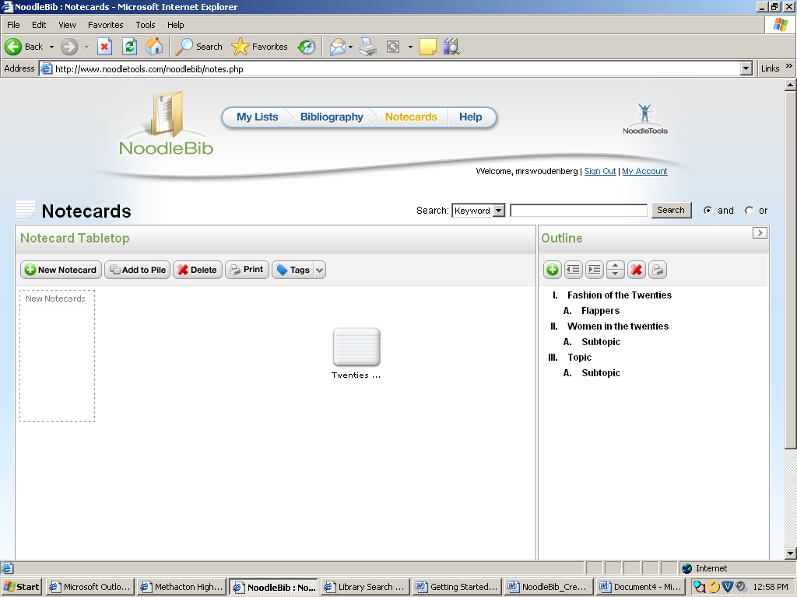Click Save to save your notecard. You can drag and drop your notecards to organize them.

Making an Outline

1. On the right side of the Notecards page, there is a window where you can make an outline.
2. Use the **+**  sign button to add lines to your outline.
3. The other buttons allow you to move and delete items, and the print button will let you save and print the outline.

**COMMON ONLINE SOURCES IN NOODLE TOOLS**

**Common Source Type How to Recognize It How to Cite It**

|  |  |  |
| --- | --- | --- |
| **Anthology – Database**  An essay/article from a collection of essays (book) on the same topic.  Most VIEWPOINT ESSAYS from the **Opposing Viewpoints Database** are from an Anthology. | **→** Look at the citation at the bottom of the database article. The title of the anthology will appear after the article title and will be in *ITALICS*. It usually has a title that has something to do with the main topic. **→** The citation usually has an EDITOR, CITY, PUBLISHING CO. and YEAR. | **→** Select or write in the name of the DATABASE used. **→** The main article title at the top of the page or what appears in “QUOTES” in the citation given is the TITLE OF SPECIFIC WORK. **→** The AUTHOR of the specific work would be the name of the person/organization that appears FIRST in the citation given. Leave it blank if an author isn’t listed. **→** The title of the anthology will appear after the article title and will be in *ITALICS*. **→** An EDITOR’S name should have Ed. in front of it and be in the middle of a citation, not the beginning. **→** Include the CITY, PUBLISHING CO., YEAR, and PAGES (if given). **→** If it was reprinted from a previous source (RPT. FROM…), you can leave out that part and only cite the specific work (article) and the anthology. |
| **Reference Source – Database**  An article/entry from an encyclopedia, almanac, dictionary, etc.  Most Reference Sources have ENCYCLOPEDIA, ALMANAC, or DICTIONARY in the title. | **→** Look at the citation at the bottom of the database article. The title of the reference book will appear after the article title and will be in *ITALICS*.  **→** The citation usually has an EDITOR, CITY, PUBLISHING CO. and YEAR and might have a VOLUME or EDITION listed. | **→** Select or write in the name of the DATABASE used. **→** The main article title at the top of the page or what appears in “QUOTES” in the citation given is the ARTICLE TITLE. **→** The AUTHOR of the article would be the name of the person/organization that appears FIRST in the citation given. Leave it blank if an author isn’t listed. **→** The title of the reference source will appear after the article title and will be in *ITALICS*. **→** An EDITOR’S name should have Ed. in front of it and be in the middle of a citation, not the beginning. **→** Include the CITY, PUBLISHING CO., YEAR, EDITION, VOLUME, and PAGES (if given). |
| **Magazine or Journal or Newspaper – Database**  An article that once appeared in a magazine, journal, or newspaper.  Magazine titles can be recognizable, like *Newsweek* or *Time*. Newspapers, too, usually have “News” in the title or sound like a newspaper. If you are not sure, you can try searching the title online to see which it is. | **→** Look at the citation at the bottom of the database article. The name of the **magazine,** **journal,** or **newspaper** will appear after the article title and will be in *ITALICS*. **→ Magazine** sources usually have an issue date like January 2012 or March/April 2000. **→ Journal** sources will have a date but will also have a volume and issue number (22.1). **→ Newspaper** sources will usually be a specific day, like 12 Jan. 2012, with the date being listed first. | **→** Select or write in the name of the DATABASE used. **→** The main article title at the top of the page or what appears in “QUOTES” in the citation given is the ARTICLE TITLE. **→** The AUTHOR of the article would be the name of the person/organization that appears FIRST in the citation given. Leave it blank if an author isn’t listed. **→** The name of the **magazine/journal/newspaper** will appear after the article title and will be in *ITALICS*. **→** Include the PUBLICATION DATE and PAGE NUMBERS (if given). **→** For **Journals**, add in the VOLUME and ISSUE, which will be in the original citation as two numbers separated by a period – like 35.7 – with 35 bring the volume and 7 being the issue number. **→ Newspaper** sources will usually include the page number, but may have a letter before it. “A8” would be the page number. If it is a specific section, like business or sports, then include that in the section spot. |
| **Original Content – Database**  Information that has never appeared in print before, and was created solely for the database.  Database content titles usually include something like “Online Collection.” | **→** Look at the citation at the bottom of the database article. If there does not appear to be any publishing information (editor, author, etc.) or the name of another work, like a **magazine,** **newspaper, or book,** then it is was probably created as original content for the database. | **→** Select DATABASE as the citation type, and then scroll to the bottom and select ORIGINAL CONTENT. **→** When filling out the citation form, select or write in the name of the DATABASE used. **→** The main article title at the top of the page or what appears in “QUOTES” in the citation given is the ARTICLE TITLE. **→** Include the name of the PUBLISHER and the date of publication (YEAR) if given. |

**COMMON PRINT SOURCES IN NOODLE TOOLS**

**Common Source Type How to Recognize It How to Cite It**

|  |  |  |
| --- | --- | --- |
| **Anthology – Print**  A printed book that has a collection of essays or stories on the same topic but which are usually not from the same author.  Most books that focus on controversial issues are ANTHOLOGIES. | **→** Look at the Table of Contents. If each chapter or section is a separate essay with a separate author, than it is an ANTHOLOGY. **→** On the cover or title page, an anthology will usually list an EDITOR or COMPILER instead of an author. | **→** Include the TITLE OF SPECIFIC WORK and its specific AUTHOR if it is known which article/chapter is going to be cited. **→** The name of the entire book is the title of the ANTHOLOGY. **→** Look on the book’s TITLE PAGE for the EDITOR and PUBLISHER (company name). Use the first city listed on this page as the CITY of PUBLICATION. **→** The YEAR of PUBLICATION or copyright date should appear on the following page, which is the copyright page. **→** Include the PAGES that the specific work or article is on. **→** If it was reprinted from a previous source (magazine, newspaper, etc.), you do not need to cite that, only the anthology. |
| **Reference Source – Print**  An article/entry from an encyclopedia, almanac, dictionary, etc.  Most Reference Sources have ENCYCLOPEDIA, ALMANAC, or DICTIONARY in the title. | **→** The reference book may be large, found in the reference section, or part of a multivolume set. **→** Most reference books have an EDITOR or group of EDITORS, and not one main author. **→** Only one small entry, section, or article is being used from the book. | **→** Include the ARTICLE/ENTRY TITLE and its specific AUTHOR if there is one given. (Most reference articles do not include an author, but if they do, it is usually with the entry and not at the beginning of the entire book.) **→** Include the PAGES that the specific work or article is on. **→** Look on the book’s TITLE PAGE for the EDITOR(S) of the entire reference book and the PUBLISHER (company name). Use the first city listed on this page as the CITY of PUBLICATION. **→** The YEAR of PUBLICATION or copyright date should appear on the following page, which is the copyright page. **→** Include the VOLUME number, SERIES name, or EDITION (if given). |
| **Book – Print**  A traditional book that is usually on one topic or idea with one author or group of authors. Most book sources do not have an editor, but may have a translator. | **→** On the table of contents, the chapters listed are not each written by a separate person on a separate idea. Instead, it is just the flow of one chapter to the next, all within the same main topic. | **→** Look on the book’s TITLE PAGE for the complete title of the book and its AUTHOR.  **→** The title page will also include the PUBLISHER (company name) and the CITY of PUBLICATION. Use the first city listed if there are more than one. **→** The YEAR of PUBLICATION or copyright date should appear on the following page, which is the copyright page. |

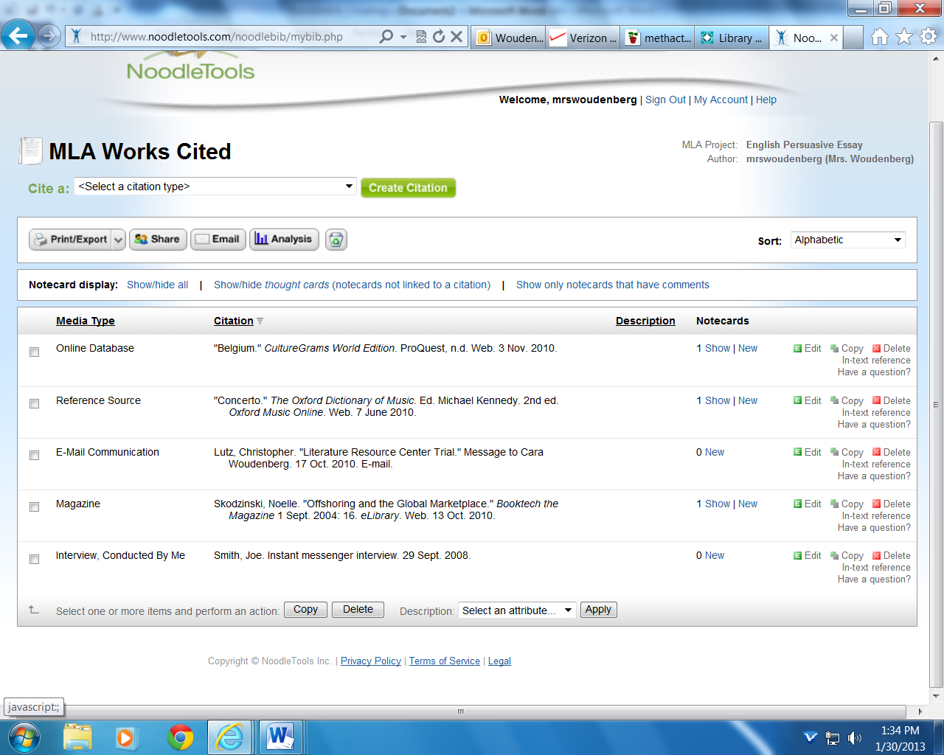SAMPLE WORKS CITED  
Note that you can learn what your in-text citation should look like by clicking on the link to the right of each source in your Works Cited list that says “In-text Reference.”

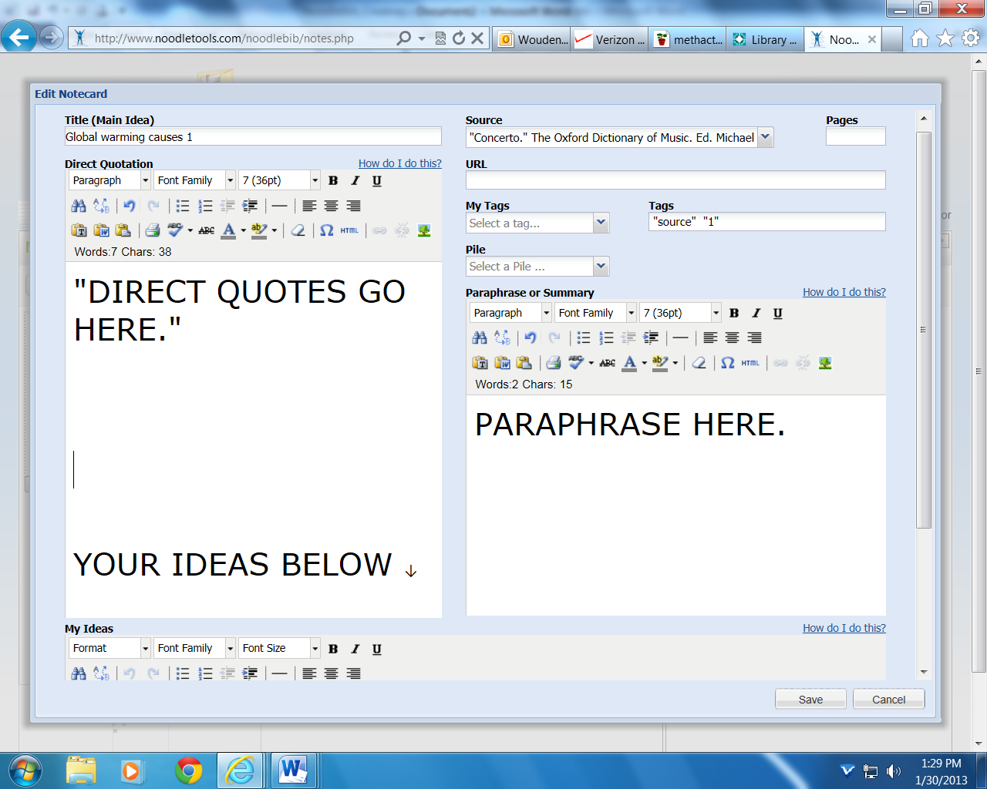  
Sample Notecard